**Module 4**

* **Which components have you used in Load Runner?**

Virtual Generator

Analyzer

Controller

Load generator

* **How can you set the number of Vusers in Load Runner?**

You can set the number of Vusers **in the controller section while creating your scenarios**.

* **What is Correlation?**

Correlation is **the process of extracting some value from the response of one step into the request of another step.**

* **What is the process for developing a Vuser Script?**

1-recording the vuser script .  
  
2-edit the vuser script.  
  
3-runtime setting .  
  
4-run the vuser script in stand-alone mode.  
  
5-incorporate the vuser script into a load runner scenario.

* **How Load Runner interacts with the application**
* **How many VUsers are required for load testing?**

Concurrent virtual user calculation  
  
For example, if you run a load test with **10,000 virtual users**, each making a request every 20 seconds (3 requests per minute), then you're making 30,000 requests per minute, which equals 500 requests persecond.

* **What is the relationship between Response Time and Throughput?**

The response time for an average transaction tends to decrease as you increase overall throughput.

* **What is the difference between hits/second and requests/second?**

Hits per second means the number of hits the server receives in one second from the vuser. Request per second is the number of request the vuser will request from the server.

* **What is Automation Testing?**

Test automation is the use of software to control the execution of tests, the comparison of actual outcomes to predicted outcomes, the setting up of test preconditions, and other test control and test reporting functions.

• **Which Are The Browsers Supported By Selenium Ide?**

All different browsers supported by selenium ide.

* **What are the benefits of Automation Testing?**

70% faster than the manual testing

Wider test coverage of application features

Reliable in results

Ensure Consistency

Saves Time and Cost

Improves accuracy

Human Intervention is not required while execution

Increases Efficiency

Better speed in executing tests

Re-usable test scripts

Test Frequently and thoroughly

More cycle of execution can be achieved through automation

Early time to market

* **What are the advantages of Selenium?**

Very easy to use and install.

No programming experience is required, through knowledge of HTML and DOM are needed

Can export tests to formats usable in Selenium RC and WebDriver

Has built-in help and test results reporting module.

Provides support for extensions.

* **Why testers should opt for Selenium and not QTP?**

Below are the reasons for tester should opt selenium and not QTP

|  |  |
| --- | --- |
| * **Selenium** | * **QTP** |
| Open source, free to use, and free of charge | It is Open source, free to use, and free of charge |
| Highly extensible | Limited add-ons |
| Can run tests across different browsers | Can only run tests in Firefox , Internet Explorer and Chrome |
| Supports various operating systems | Can only be used in Windows |
| Supports mobile devices | Supports mobile devise using 3rd party software |
| Can execute tests while the browser is minimized | Needs to have the application under test to be visible on the desktop |
| Can execute tests in parallel. | Can only execute in parallel but using Quality Center which is again a paid product. |

* **To validate the tops technologies website Contact us page and enter your friend detail at last “Guest Call Back”** [**https://www.tops-int.com/contact-us/**](https://www.tops-int.com/contact-us/)

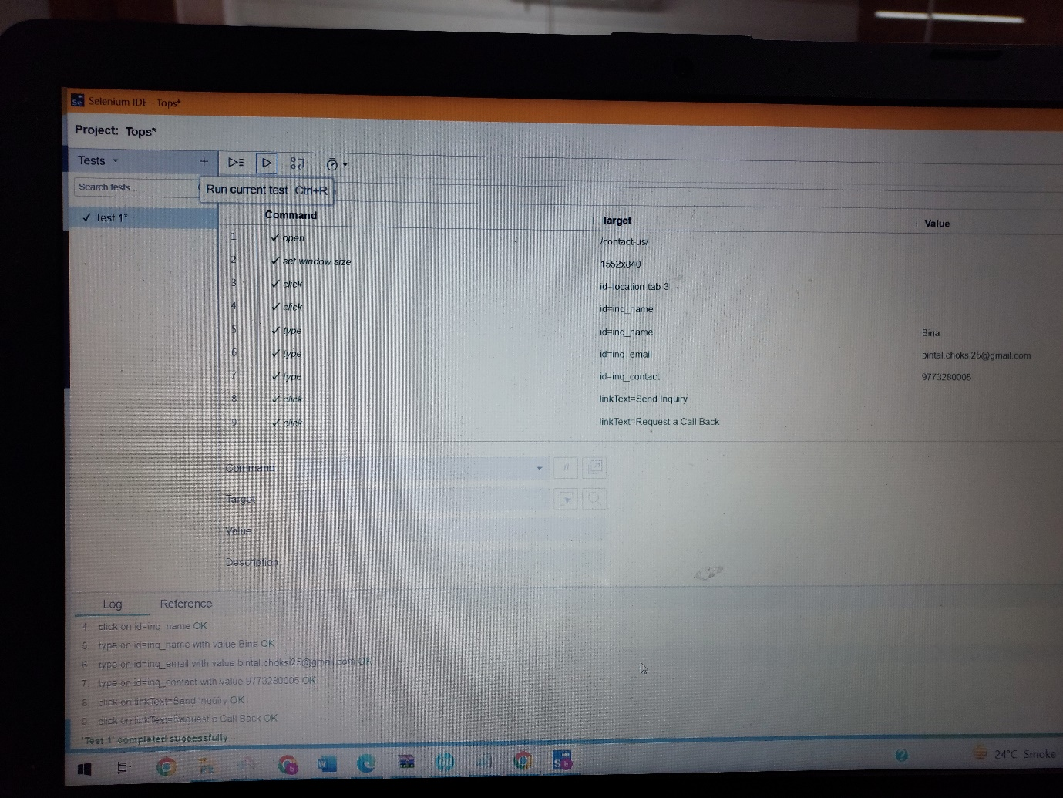

**Link of script**

**https://drive.google.com/file/d/156bzgpxkYGO44aSUWnGQyvVK_tfdpIMx/view?usp=share_link**